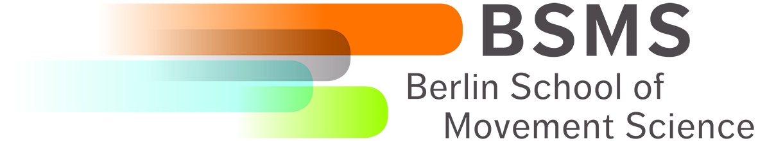

3rd International Autumn School on Movement Science
Berlin, 3rd to 8th October 2016

The Berlin of Movement Science (BSMS) organizes an International Autumn School on Movement Science for young scientists to give first-hand experience of the unique graduate training program in the field of movement science. The next International Autumn School on Movement Science will take place in Berlin from the 3rd to the 8th of October 2016. In this Autumn School, we want to provide an overview on movement viewed from different perspectives such as the brain, central nervous system, bone, muscle and spine as well as is associated diseases and therapies using physical activity.

Travel grant application form

The BSMS provides 10 travel grants to invite Master’s and PhD students from all over the world to participate in this Autumn School. The travel grants will cover travel expenses and accommodation. The Autumn School will be of particular interest to those Master’s and PhD students who are considering doing their doctoral or post-doctoral research in the field of movement science within our network. The 10 travel grants will be awarded depending on the quality of the application, merit and the relevance.

Requirements

The BSMS invites applications from students with a Bachelor, Master or PhD degree in biology, bioengineering, biomechanics, physics, sports science, medicine who have a special interest in movement science. Priority is given to those students who are at the end of their Master’s or PhD studies with a special interest to gain first-hand experience of the graduate training programme of the BSMS.
- Participants with a Bachelor degree should be advanced level and carry out their Master thesis.
- Participants with a Master degree should be doing their PhD or planning to do their PhD.
- Participants with a PhD degree should only have recently graduated (less than one year).

How to apply

If you have any questions regarding the requirements or the application procedure, please do not hesitate to contact the coordinator. This will avoid your application being rejected simply because you did not follow the required procedure.

Please complete this application form, prepare one PDF file by adding the additional documents in the order they are listed here and send this one PDF file to martina.piotrowski@hu-berlin.de. The PDF file must not be larger than 10 MB. The application should include the following documents:
- this completed application form
- your CV including the addresses of two referees
- copies of certificates
- publication list (if available)
- English proficiency test (if available).
Details of Applicant  Surname  Forename  Date of Application  Personal data  Gender  Date of Birth  City of Birth  Country of Birth  Nationality  Marital Status  No. of children  E-Mail | Private adress  Street  City  Postcode  Country  Phone  (including the international code)  Mobile  (including the international code)  Address of current institute (if applicable)  Institute  Street  City  Postcode  Country  Phone  (including the international code)  E-Mail

Motivation
Please describe in your own words why you want to participate in the BSMS Autumn School, your expectations from the BSMS Autumn School, your scientific interest and your plans for your professional future. Please give also reasons why you need a travel grant. (No more than 1500 characters including spaces)

English Skills
We need to know that you have a good command of the English language. Participation in an internationally recognized test is therefore recommended but not mandatory. Please indicate which formal English test you attended and how you scored or provide any other prove of your proficiency in English.

TOEFL test

TOEFL score

TOEFL date

IELTS Test

IELTS Score

IELTS date

Other proof of proficiency in English

Accommodation
We need to know whether you will require accommodation at the Pegasus Hostel. Expenses for the accommodation at the Pegasus Hostel will be covered for participants who will receive a travel grant.

List of Contents of this Application
Please list all appendices that you have attached to your application.
Curriculum Vitae
List of own publications and presentations
Bachelor’s degree transcript
Bachelor’s degree certificate
Master’s transcript
Master’s degree certificate
Doctoral degree certificate
English proficiency test
Please list others here

